Project Ghost Login

Name: Shavit Bar
Student Code: s19
Class Code: Tmagen773647
Lecturer’s Name: Eliran Berkovich

Project Overview
Ghost Login is a bash script that takes an IP address or network, scans it for SSH, and then tries different username and password combinations on the hosts it finds, and if the login works the script connects to the remote machine, creates a small file, and saves information about the whole process into log files.

Network Discovery
1. Starting the script and finding SSH
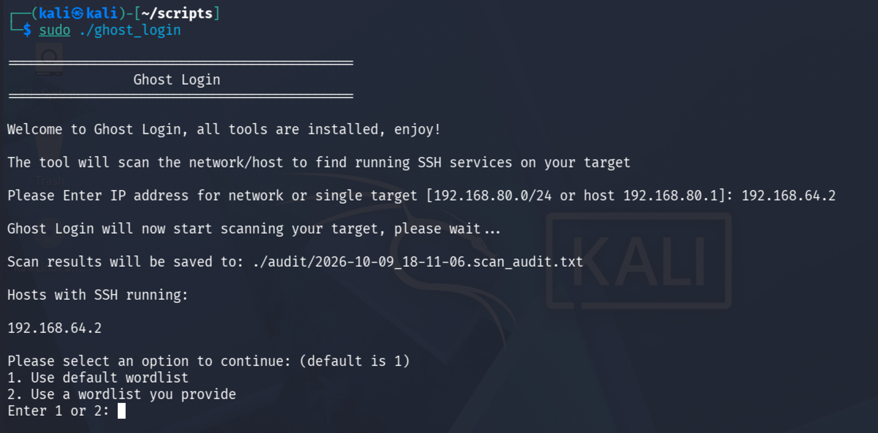
Here I ran the Ghost Login script and entered 192.168.64.2 as the target. The script scanned the target and found that SSH was running on it, it also created a scan log so the result could be checked later.

2. Nmap scan result
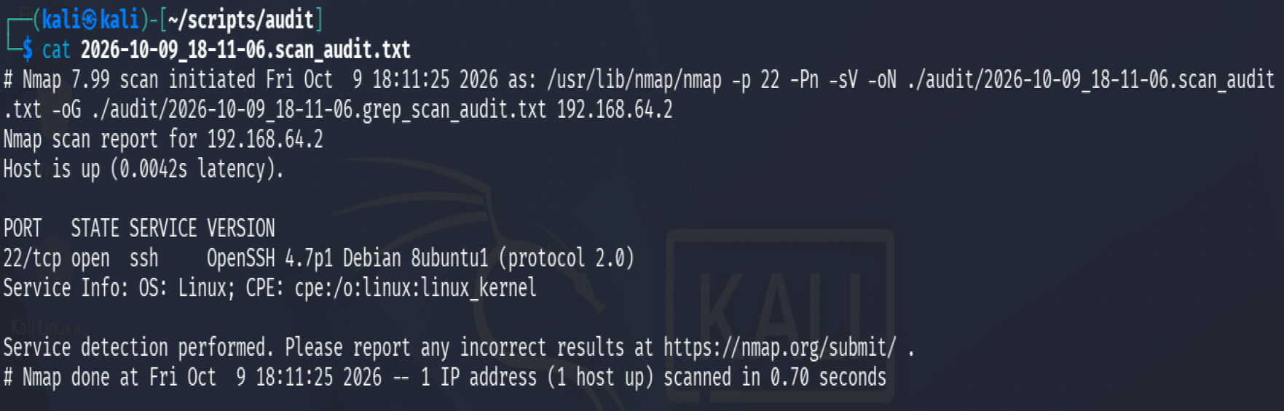
This is the Nmap scan file created by the script, it shows that port 22 is open on 192.168.64.2 and that the machine is running an OpenSSH service.

3. Brute Forcing
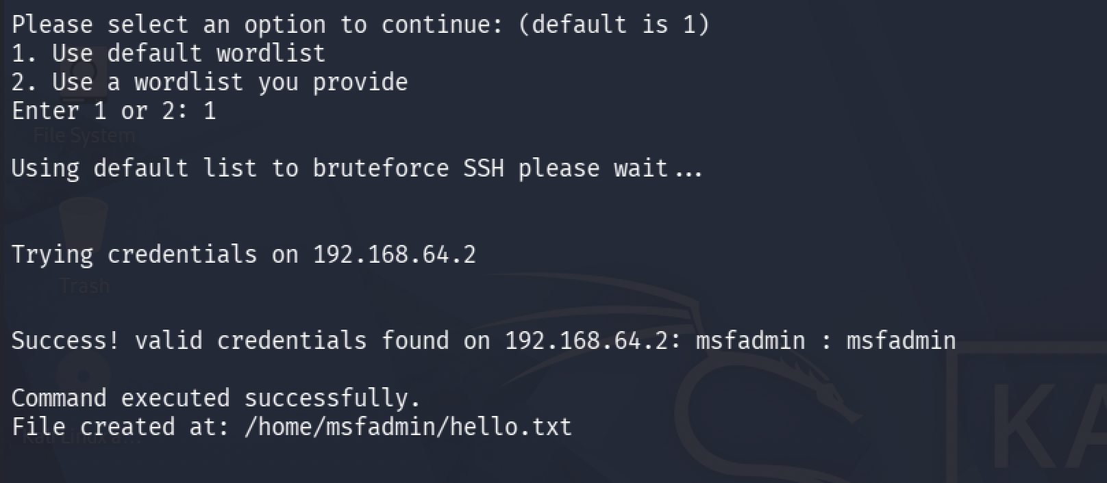
I selected the default wordlist and the script started testing the username and password combinations against the SSH service and it eventually found the correct credentials: user: msfadmin and pass: msfadmin.

After finding the correct login, the script connected to the machine and successfully run the remote command.

4. Remote Command Execution
When the correct credentials was found, the script connected to the target with SSH and created a file called hello.txt, the script also shows the location of the file, which in this run was /home/msfadmin/hello.txt.
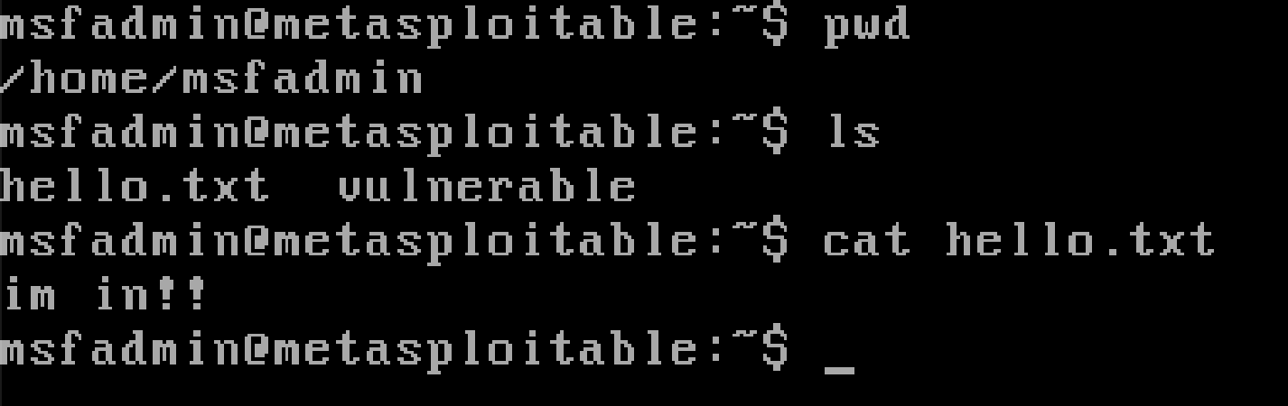
The screenshot below was taken on the remote target machine:

5. Final Report
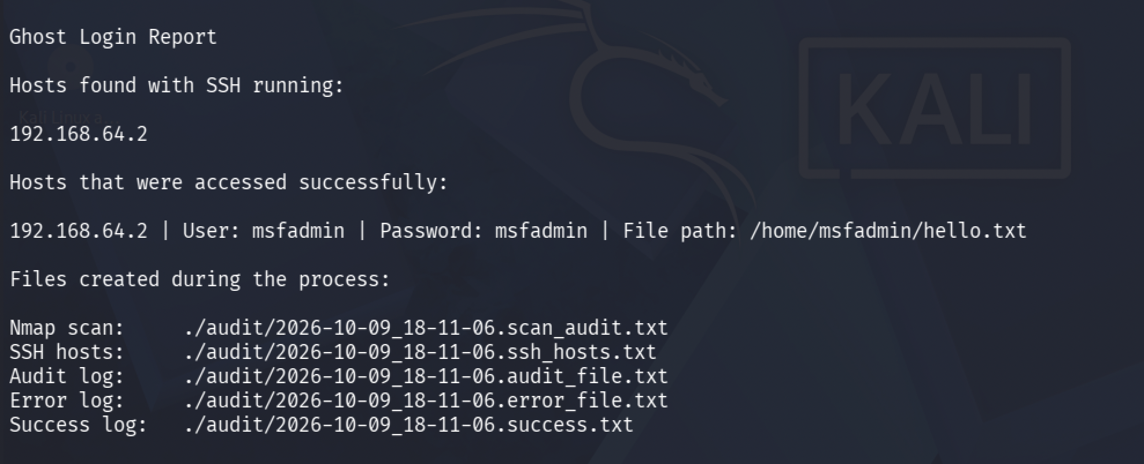
At the end of the run the script will display a report of what happened. It will show the SSH host that was found, the host that was successfully accessed, the valid username and password, the location of the file that was created, and the log files that were created during the run.

6. Created Log Files
This shows the different log files created during the same run, each file uses the same timestamp so it is easy to tell which files belong to the same execution.
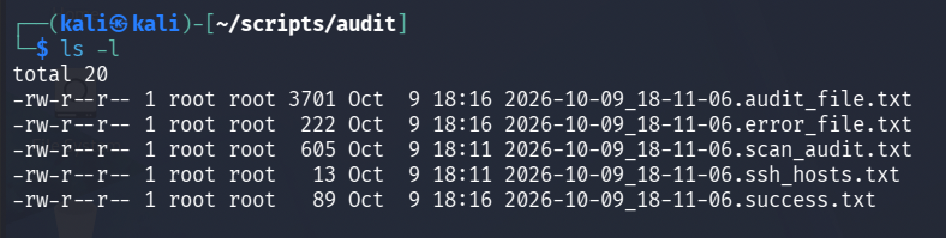
The files include the nmap scan, discovered SSH hosts, general audit information, errors, and successful login results.

6.1 scan_audit.txt
This file contains the nmap scan output, it shows the target, whether the host is up, the state of port 22, and information about the SSH service that was found. (I already included the scan_audit.txt file contents in the Network Discovery section).

6.2 success.txt
This file stores only the successful results, when the script successfully logs into a host and creates the remote file, it saves the IP address, username, password, and file path here.

6.3 audit_file.txt
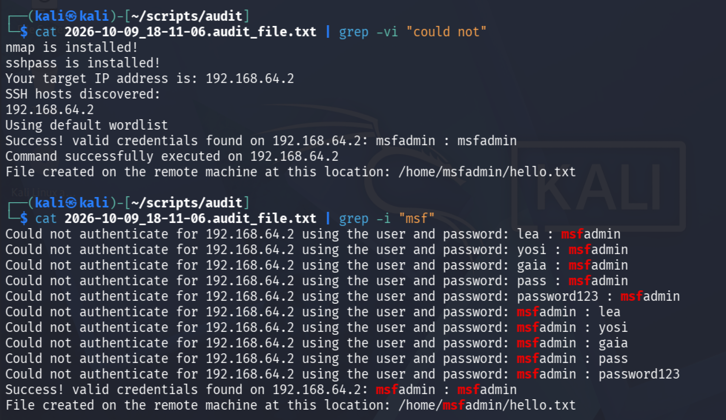
This is the main activity log file. It keeps track of what happened during the run, such as whether nmap and sshpass were installed, the target IP, discovered SSH hosts, failed login attempts, successful credentials, and whether the remote command worked.

I filtered some of the output as the file had a lot of “Could not authenticate for” entries and was too long).

NOTE: I didn’t include the other files as they didn’t have any relevent information I didn’t already cover in the other sections.

My Personal Improvement
For my personal improvement i added a timestamped logging system, which means every time the script runs, it creates separate log files for the scan results, errors, discovered SSH hosts, and successful logins. I added this because without logging, most of the information would disappear after the terminal is closed. With the log files, I can go back later and check exactly what happened during each run. I also added timestamps to the file names so that every run gets its own logs instead of overwriting the previous ones.

